
CARL J. KENNEDY BRANCH 704

THE LETTER CARRIER

REPORTER
PROUDLY SERVING
TUCSON • GREEN VALLEY • SIERRA VISTA • CASA GRANDE • SAFFORD • DOUGLAS • GLOBE •
WILLCOX • COOLIDGE • SAN MANUEL • MIAMI • BISBEE

FEBRUARY 2018 Email Address: nalcbranch704@outlook.com Printed by Branch 704

CONGRATULATIONS …
On Your Retirement!

Rick Evans Greg Hoppe Jack Howell
Coronado Station Sun Station Casas Adobes Station

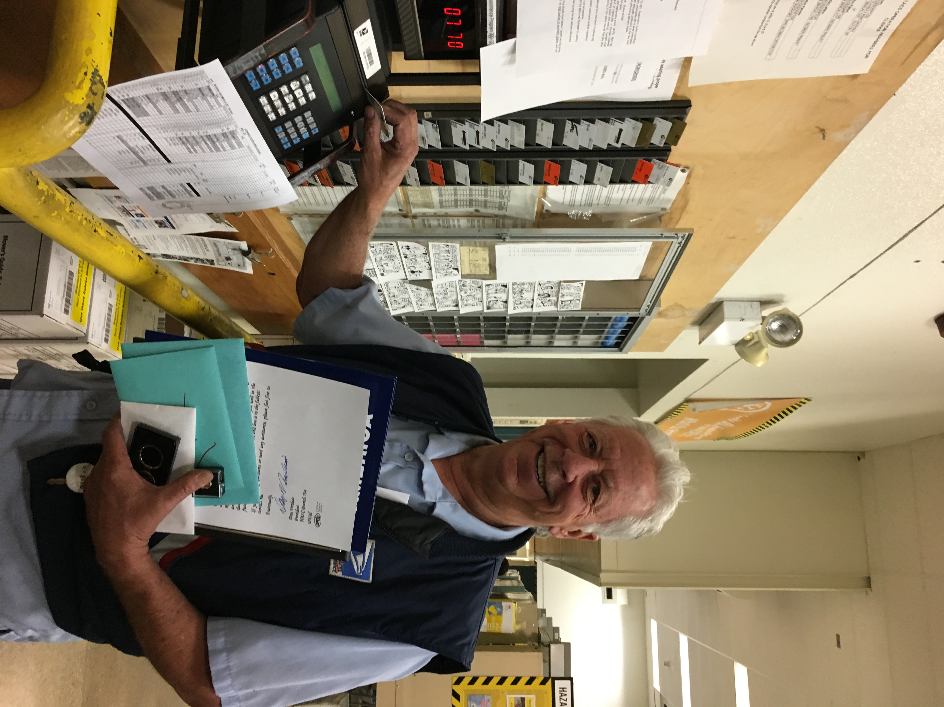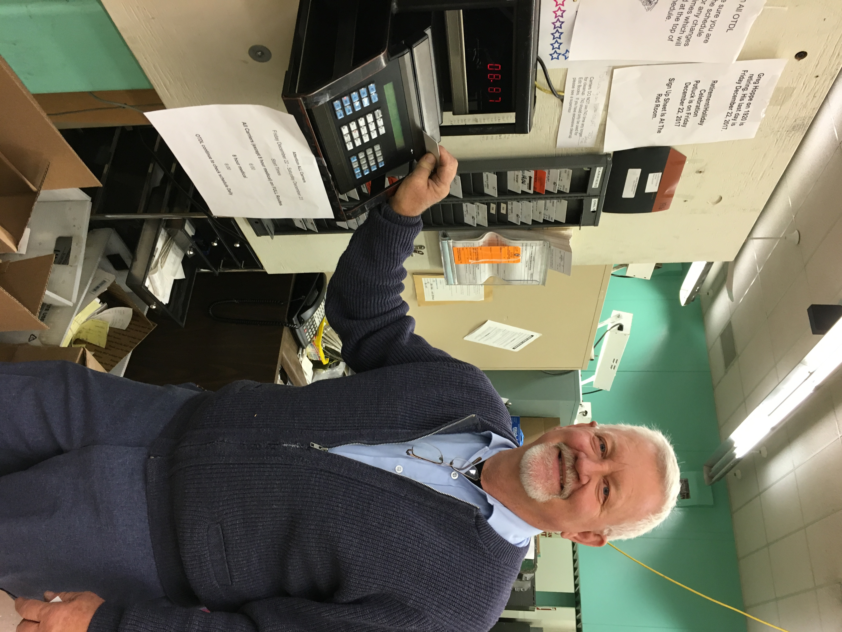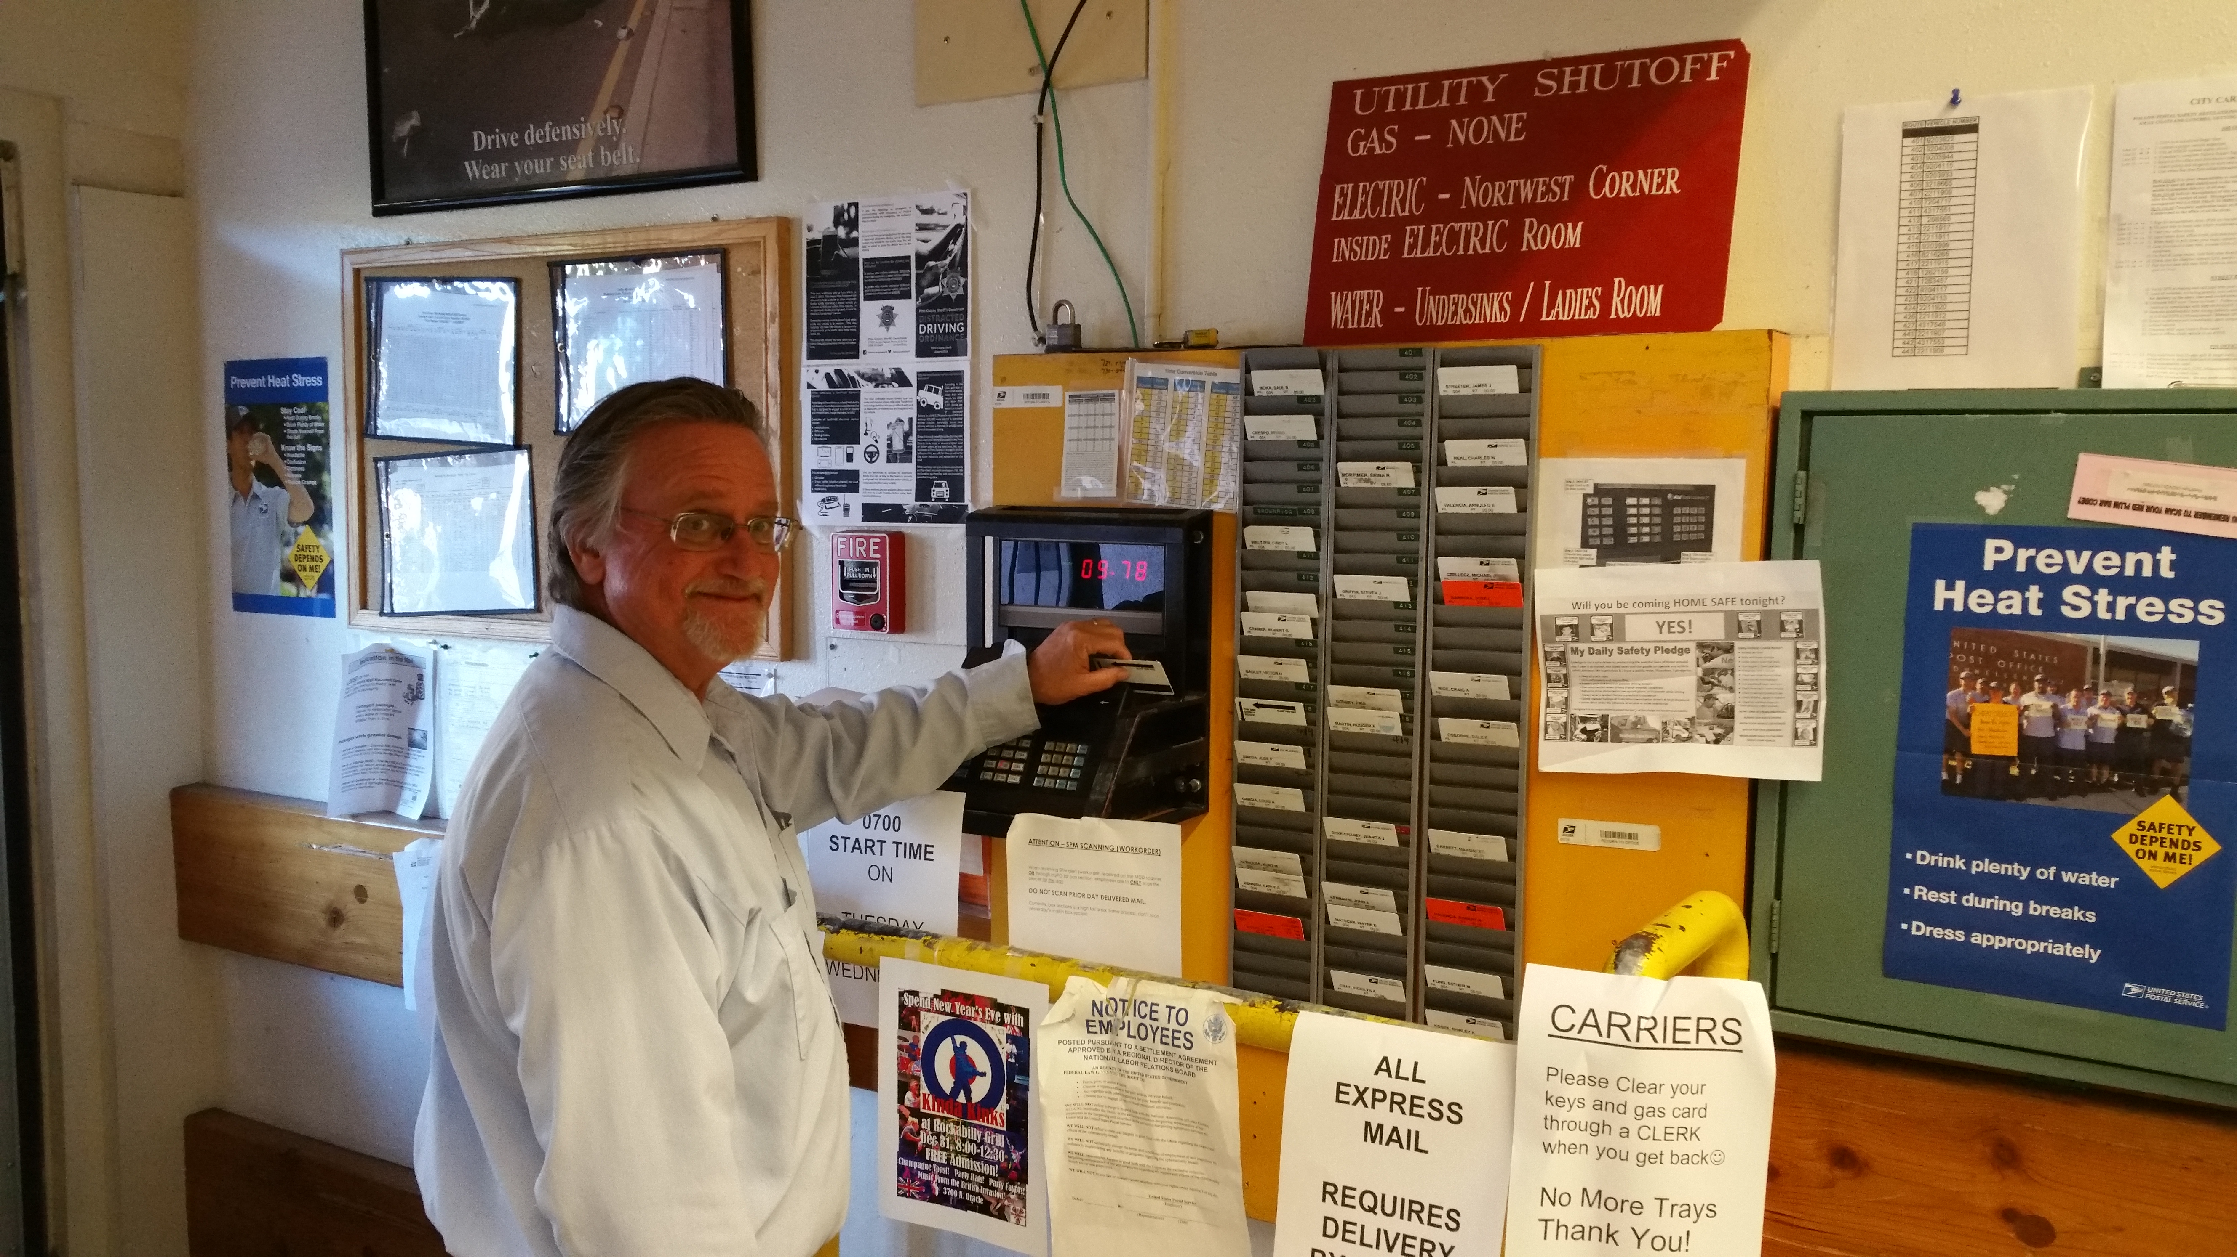

Jim Willis (not pictured)
Retired from Willcox USPS.

Next Union Meeting THURSDAY February 1, 2018, to begin promptly at 7:00 PM
2950 N. Country Club Road, Tucson, AZ 85716-1912

President’s Report

Is it a Dream or a Nightmare?
A few days ago, I woke up like normal, went to work with a smile on my face and was greeted by my supervisor and manager with an enthusiastic good morning and a positive outlook for the workload for the day. While sorting through my mail and parcels my supervisor asked me if I needed anything to help me provide great customer service and reminded me to take the time that it takes to follow all the rules, so I could perform my duties safely, efficiently, and provide the best possible service to our customers. After estimating my workload my supervisor approved my request for overtime and told me to have a good day.

My day was going great until I was delayed for about 10 minutes because of road construction and another 5 minutes because my DPS was a little messed up. I called my supervisor, who picked up the phone after two rings, to let him know I was running a little later than I thought. He thanked me for calling and told me not to worry about it because he understood and that it takes what it takes to get the job done. When I returned from the street I did my normal P.M. functions, cleared my accountable items with the red-room clerk that was waiting for me, and then went to talk to my supervisor about an inquiry from a customer that I did not know the answer for. My supervisor thanked me for bringing the issue to his attention and let me know that he would have the answer for me first thing in the morning. He also thanked me for doing a great job for the day.

Oh no!!! My alarm just went off and I quickly realized that I was just having a dream. I had to shake my head back to reality. The thought of having to deal with, in many cases, the most adversarial employer I have ever worked for just hit my stomach and made me physically sick. So much for the good dream and back to the daily nightmare!

Thankfully we have our Union and the perseverance and dedication of many of our members, stewards, and officers who band together in solidarity to bring justice to the job. We cannot ever give up attempting to make the Post Office a better place to work despite manage-ment’s efforts to inflict negativity at our every turn.

January Branch meeting and Installation of Officers
For the first time since becoming a member of the NALC the officers and members of our branch decided to have the Installation of Officers at the January 4th Branch meeting. Mama’s Hawaiian Barbeque was brought in to start the evening off. Our National Director of Safety and Health, Manny Peralta, conducted the Installation of Officers and gave the members in attendance some important and inspiring words of wisdom. Thank you, Manny! I also want to thank Trustee Pete Tadeo and his wife for setting up the caterer and helping out with making things run smooth.

A big thank you goes out to Brother John Troutwine for his dedication to the Branch as Trustee for the past three years. John not only fulfilled his responsibilities as Trustee but was there for the Branch every time we called on him. John was nominated in October but withdrew his name from consideration to allow a younger carrier, Claudio Retes, also from the Green Valley Post Office to get his feet wet with the admin-istration end of the Branch. Thank you, John!

Until next month, be safe, and CYA.

Fraternally,
Dan Versluis

Meeting Dates

Branch Meeting-Thursday,
February 1, 2018 @ 7:00 pm

Stewards Meeting-Thursday,
February 15, 2018 @ 5:30 pm

Executive Board Meeting-
Thursday, February 22, 2018
@ 6:00 pm

Vice President Article

Greetings Brothers and Sisters,
Happy New Year! Congratulations to all the officers and new stewards elected. We have a new web master who will be working on our web page to look forward to this new year. I also want to thank John Troutwine for all his help and dedication throughout the past years, we will miss you. Welcome our new members to the e-board.

I want to thank our Formal Step A Reps Stuart Love and Bill Lamb for representing us all each and every day. They work for our members in a very high stress environment and I want to thank you for your perseverance in the face of adversity and your commitment to our branch.

National Director of Safety and Health, Manny Peralta conducted the installation of officers and talked about how important it is to make sure we don’t give up our union rights that were and are so hard won. He talked about the NALC history and how we cannot give up the fight to adhere to the contract. He mentioned that we have the respon-sibility to make sure we don’t let violations of the contract go because it is easier or because we are afraid we will be a target by management if we say anything. I have to agree with him if everyone lets some violations on the contract go without addressing them by the union we are doing a disservice to all union members that have helped, fought, marched, gone on strike for us over the years and it weakens our contract and ability to affect change. To affect change takes you and your participation to act to insure we are grieving violations of the contract. Thank you, Manny Peralta, for your presence and time and your reminder to us to not give up the fight.

We closed out the year with less accidents this year than last year so that’s great everyone, but we still have work to do. Let’s strive to improve our workplace and safety this year. Don’t get complacent and let the little things go by because they may not seem as important, safety is very important so is your health, and the wellbeing of everyone around you, including our customers, let’s make sure we do as much as we can to improve things at work. After all we work to live the life we want not the other way around, this is a high stress work; let’s not make it more stressful but work to eliminate it.

In closing stay active in our union, be safe at work, let’s be thankful for what we have but fight to make it better, and appreciate everyone’s efforts.

In Solidarity,
Kathy Walter

PYRAMID FEDERAL CREDIT UNION

Improve your financial life!
5 Convenient locations to serve you!

Contact Us Today (520) 795-7950
24 Hour account access at www.pyramidfcu.org

Auto Rates
As Low As 2.25% APR*
Get Preapproved Today!
5801 E Broadway Blvd.
Mon-Thurs. 9am to 5pm
Friday 9 am to 6 pm, Sat 9 am to 1pm

4491 N Oracle Rd.
Mon-Thurs. 9 am to 5 pm
Friday 9 am to 6 pm

8235 S Houghton Rd.
Mon-Thurs. 9 am to 5 pm
Friday 9 am to 6 pm, Sat 9 am to 1 pm

7740 E Speedway Blvd.
Mon-Thurs. 9 am to 5 pm
Friday 9 am to 6 pm

5280 E Grant Rd.
Mon, Tues, Thurs. 730 am to 4 pm
Wed 9 am to 4 pm, Fri 730 am to 5 pm

*APR= Annual Percentage Rate. Rate current as of 8/1/2017. Subject to change. Based on credit history.

Formal Step-A Report

During the month of December, 94 grievances were re-solved at the Formal Step-A level.

A summary of the settled grievances is listed below:

FORMAL STEP-A:

- Settled 16 Letters of Warning (L.O.W.) by getting 2 rescinded, 5 reduced to an Official Discussion, 1 re-duced to a 1 1/2-month L.O.W., 1 reduced to a 32-Day L.O.W., 1 reduced to a 38-Day L.O.W., 1 re-duced to a 45-Day L.O.W., 3 reduced to a 3-month, L.O.W. 2 reduced to a 6-month L.O.W.
- Settled 3 14-Day Suspensions getting 1 reduced to a 1 year 7-Day Suspension, 1 reduced to 1-year L.O.W., 1 reduced to 18-month L.O.W.
- Settled 4 7-Day Suspensions getting 1 reduced to a 1 year 7-Day Suspension, 1 reduced to a 6-month L.O.W., 1 reduced to a 4-month L.O.W., and 1 rescinded.
- Settled 23 grievances where management improperly forced non-ODL carriers to work overtime by getting those carriers paid the appropriate premium payment and ODL carriers paid for the missed opportunities (Total: 10,956.54).
- Settled 2 grievances where Management placed car-riers on Emergency Placement 16.7s by getting the Emergency Placements rescinded and the carrier paid if warranted (Total 71.12)
- Settled 12 grievances where management was per-forming bargaining unit work by getting those carriers who should have done the work paid (Total 2,989.87)
- Settled 4 grievances where management improperly took away work assignment overtime, giving it to ODL carrier by getting W/A carrier paid for lost overtime (Total 143.93)
- Settled 3 grievances where management failed to provide Steward time to process grievance by getting that Steward paid for processing a grievance off the clock. (Total 250.33)
- Settled 1 grievance, management failed to do a search for work for a light duty request by getting that carrier paid for hours she could have worked. (Total 443.28)
- Settled 4 grievances where management failed to allow carriers to work the Scheduled hours of the opt by getting those carriers paid (Total 726.80).
- Settled 11 grievances, RCAs were performing City Carrier work delivering Amazon parcels by getting carriers who should have done the work paid. (Total 1,290.77)

We appealed 3 grievances to Step B in December.
We received 2 Step B decisions back this month.
1 grievance was impassed.
1 grievance was sustained in the union’s favor which management was having RCAs delivering Amazon parcels on city routes. (Total 106.22)
We received 2 pre-Arb decisions back this month.
1 where management failed to follow pecking order for an on the job injury. Carrier was awarded out of schedule pay for all hours worked outside his regular schedule Total (5,060.24)
1 where management failed to place grievant in a pay status during the notification period pending removal. The grievant was awarded approximately (11,004.80)

Management’s failure to follow the contract cost the USPS $ 33,043.90 this month.

There are 134 grievances outstanding at Formal Step-A.

In Solidarity,
Stuart Love
Formal Step-A Representative

Attention Postmaster, 1 Monthly issue consisting of at least 25% non-advertising matter in each issue of the Carl J. Kennedy Branch 704,
The Letter Carrier Reporter Volume 2018-02
Issue #02; Organization:
National Association of Letter Carriers,
2950 N. Country Club Road,
Tucson, AZ 85716-1912

Law Offices of Stephen J. Dunn

ANALESE B. DUNN
Attorney at Law

Concentrating in legal representation
For federal employees

FEDERAL WORKERS’ COMPENSATION
(OWCP)

OFFICE OF PERSONNEL MANAGEMENT

DISABILITY RETIREMENT

U.S. MERIT SYSTEMS PROTECTION BOARD
EQUAL EMPLOYMENT OPPORTUNITY
COMMISSION

Phone (623) 594-8351 / (410) 321-8368
Fax (410) 321-1599

Email: abdunn@sdunnlaw.com

www.sdunnlaw.com

CONGRATULATIONS

On Your Conversion to Career City Carrier!

Frank Lopez III
Abel Cervantes
Marina Lee
Mario Murrieta
Tammy Tysver
Diana Collins
Renee Hill
Evarardo Littlefield, Jr.

Branch 704 Installation of Officers by Manny Peralta (NALC Director
of Safety & Health) at the Membership Meeting on January 4, 2018
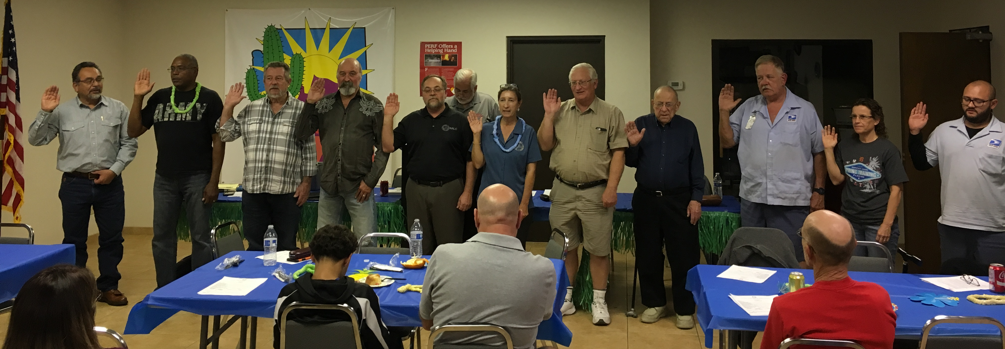

Contract Talk
Vacation Bidding

The 2018 leave year is upon us and the process for bidding annual leave in Tucson should be occurring in your station.

On February 1, 2018 your Union Steward and man-agement should be meeting to determine the leave quota for your station for the upcoming leave year. The leave quota for the Tucson Installation is 12% of the letter carriers including CCAs on the station rolls as of February 1 of each year.

Management will accept Choice Vacation bid leave submissions beginning February 1, 2018 through the close of business on March 1st, 2018.

Each regular carrier may make the following selections during the Choice Vacation bidding: (1) One 5-day period or two 5-day periods (2) One 10-day period (3) One 10-day period and one 5-day period (4) One 15-day period. No employee may select three separate five-day periods prior to the established deadline. No employee may be scheduled in excess of entitled choice selection leave if such scheduling deprives another employee of an entitled choice during the choice selection period. Scheduling of annual leave for the Choice Vacation Selection period shall be by bidding seniority/relative standing within each unit. Employees ineligible by seniority/relative standing for their choice selection(s) shall be consulted and allowed another choice before scheduling junior employees for annual leave during the choice selection period.

Submission for annual leave will be done in triplicate on PS Form 3971. The second copy of Form 3971 will show the action taken (approved/disapproved) and be returned to the employee no later than April 1st.

Requests for annual leave for full week leave periods, after the completion of the Choice Vacation Selection period, are limited only by the individual employee’s leave balance and the leave (%) quota. These non-choice submissions begin each April 1st and may be submitted up to the close of business of the Tuesday prior to the affected service week. This was extracted from the Tucson Local Memorandum of Understand-ing. The big changes this year is that CCAs are now fully included in the leave process. This means that CCAs are counted along with regular carriers in determining the quota % and being able to submit for Choice and Incidental Leave with everyone else.

CCAs should be smart when selecting their Choice Leave to make sure they will have a leave balance when their Choice or Incidental Leave selection begins. CCAs will have to consider the timing of their 5-day break since their leave balance is paid out in full as terminal leave when they take their 5-day break.

Associate Offices, please check your Local Memoran-dum of Understanding and if you have any questions, please feel free to contact your steward or the Union Office.

In Solidarity,
Dan Versluis

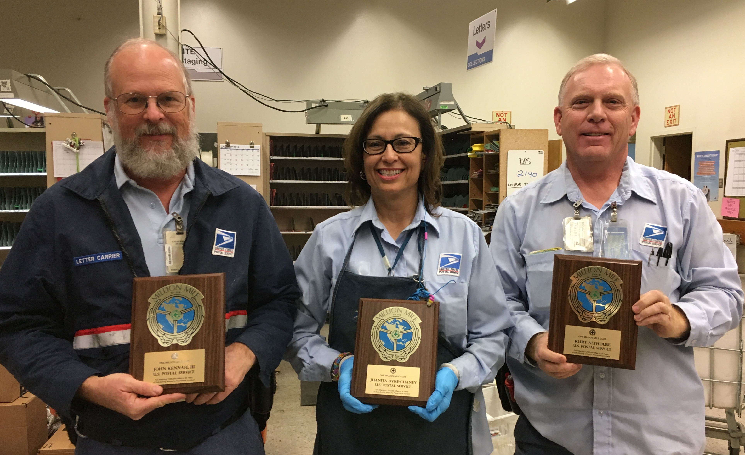
On your Million Mile Awards!

John Kennah,
Juanita Dyke-Chaney and
Kurt Althouse

Health Benefit Report
Can Hormones Help?

You may have heard that taking hormones can help you maintain muscle. One analysis found that testosterone replacement therapy (TRT) could have beneficial ef-fects on muscle mass and strength in men younger than 50 with low testosterone. Potential TRT risks in older men include excess red blood cells and worsening prostate cancer and sleep apnea. The FDA has warned that TRT may increase heart attack and stroke risks. Estrogen therapy (ET) boosts muscle strength in post-menopausal women, but long-term ET increases the risk of endometrial cancer and estrogen/progestin therapy (EPT) is linked to a higher breast cancer risk. Oral hormone therapy is also associated with an increased risk of stroke. So, if you are con-sidering hormone therapy, be sure to discuss its potential risks and benefits with your doctor.

January is Cervical Health Awareness Month
Cervical Health Awareness Month is a chance to raise awareness about how women can protect themselves from HPV (human papillomavirus) and cervical cancer. HPV is a very common infection that spreads through sexual activity. It's also a major cause of cervical cancer. About 79 million Americans currently have HPV. Many people with HPV don't know they are infected. And each year, more than 11,000 women in the United States get cervical Cancer.
The good news?
- The HPV vaccine (shots) can prevent HPV and are covered at 100% age 9 through 21.
- Cervical cancer can often be prevented with regular screening tests (called Pap tests) and follow-up care. These are covered under the Plan at 100% age 21 through 65, one annually or over age 65, one every two years.

The best of health to you and yours,
Ray Root
885-4983

Chaplain’s Corner

" And now we begin to see what it is that the New Testament is always talking about. It talks about Christians 'being born again'; it talks about them
'putting on Christ'; about Christ 'being formed in us'; about our coming to 'have the mind of Christ'. Put right out of your head the idea that these are only fancy ways of saying that Christians are to read what Christ said and to try to carry it out- as a man may read Plato or Marx said and try to carry it out. They mean some-thing much more than that. They mean that a real Person, Christ, here and now, in that very room where you are saying your prayers, is doing things to you.

It is not a question of a good man who died two thousand years ago. It is a living Man, still as much a man as you, and still as much God as He was when

he created the world, really coming and interfering with
your very self; killing the old natural self in you and replacing it with the kind of self He has. At first, only for moments. Then for longer periods. Finally, if all goes well, turning you permanently into a different sort of thing; into a new little Christ, a being which, in its own small way, has the same kind of life as God; which shares in His power, joy knowledge and eternity.'' C.S.Lewis

Many Blessings,
Chaplain Rick Evans
520-248-9643 Rick7evans@gmail.com
with Martha Evans

National Association of Letter Carriers
Carl J. Kennedy Branch 704
2950 N. Country Club Road
Tucson, AZ 85716-1912
Telephone: 520-323-2117

ADDRESS SERVICE REQUESTED

NON-PROFIT ORGANIZATION
U.S. POSTAGE
TUCSON, AZ
PERMIT 982

BRANCH OFFICERS

DAN VERSLUIS PRESIDENT
KATHY WALTER VICE PRESIDENT
DON HICOK RECORDING SECRETARY
AMBER UNDERWOOD FINANCIAL SECRETARY
BILL LAMB TREASURER
RAY ROOT HBA REPRESENTATIVE
GENE KELLEY RETIREE REPRESENTATIVE
MARK FOLLET SERGEANT-AT-ARMS



TRUSTEES

PETE TADEO
MIKE CARNAHAN BRUCE JENKINS
CATHY POULIN CLAUDIO RETES

CHAPLAIN

RICK EVANS
FORMAL A REPRESENTATIVE
STUART LOVE 323-2117
SHOP STEWARDS

VACANT | BISBEE | 520-432-2626
WADE ALFORD | CASA GRANDE | 520-836-7221
BOB CRAMER | CASAS ADOBES | 531-0693
VINCE TRUJILLO | CHERRYBELL | 388-5182
GEORGE DALEY | COOLIDGE | 520-723-3011
MARK FOLLET | CORONADO | 571-7245
DIMAS GONZALEZ | CORONADO | 571-7279
MEMO TERAN | DESERT FOOTHILLS | 615-9032
VACANT | DOUGLAS | 520-634-3631
VACANT | FT LOWELL | 290-9723
JUSTIN BRANDT | GLOBE | 928-425-2381
CLAUDIO RETES | GREEN VALLEY | 648-0095
LILLIAN VALDEZ | MISSION | 889-8828
CATHY POULIN | MOUNTAIN VIEW | 744-7097
PATRICK TOMS | RINCON | 296-2816
MICHELLE LOPEZ | RINCON | 296-1279
WENDY ZWEIACHER | SAFFORD | 928-428-0220
GARY HAMMONDS | SAN MANUEL | 520-385-9341
VACANT | SAN XAVIER | 883-3284
FRED DEPUE SR | SIERRA VISTA | 520-458-0554
KATHY WALTER | SILVERBELL | 388-9257
ALFREDO DELGADO | SILVERBELL | 388-9572
JC MENA | SUN | 881-1276
JOE SCARAMELLA | SUN | 881-1254
VACANT | WILLCOX | 520-384-2689

